**Web Technology (RCA-302)**

**Session 2020-21**

**LAB Practical List**

1. Write an HTML page that have a text box prompting to enter a number and it returns the sum of its digit as alert.
2. Write an HTML page that have a prompt box prompting to enter a number and generates an error if anything other than number is entered otherwise checks whether the number is prime or not as an alert.
3. Write a web page that contains a text field to enter the email id. When user click the submit button it validates the email id.
4. Design the page as follows:

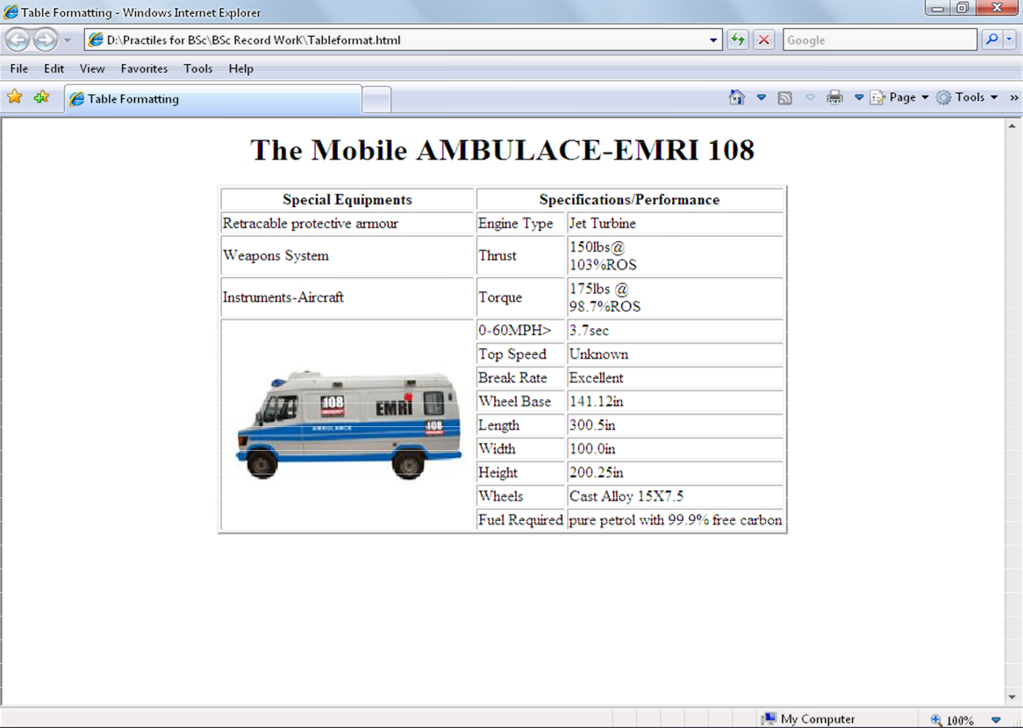

1. Using Table related tags align the images

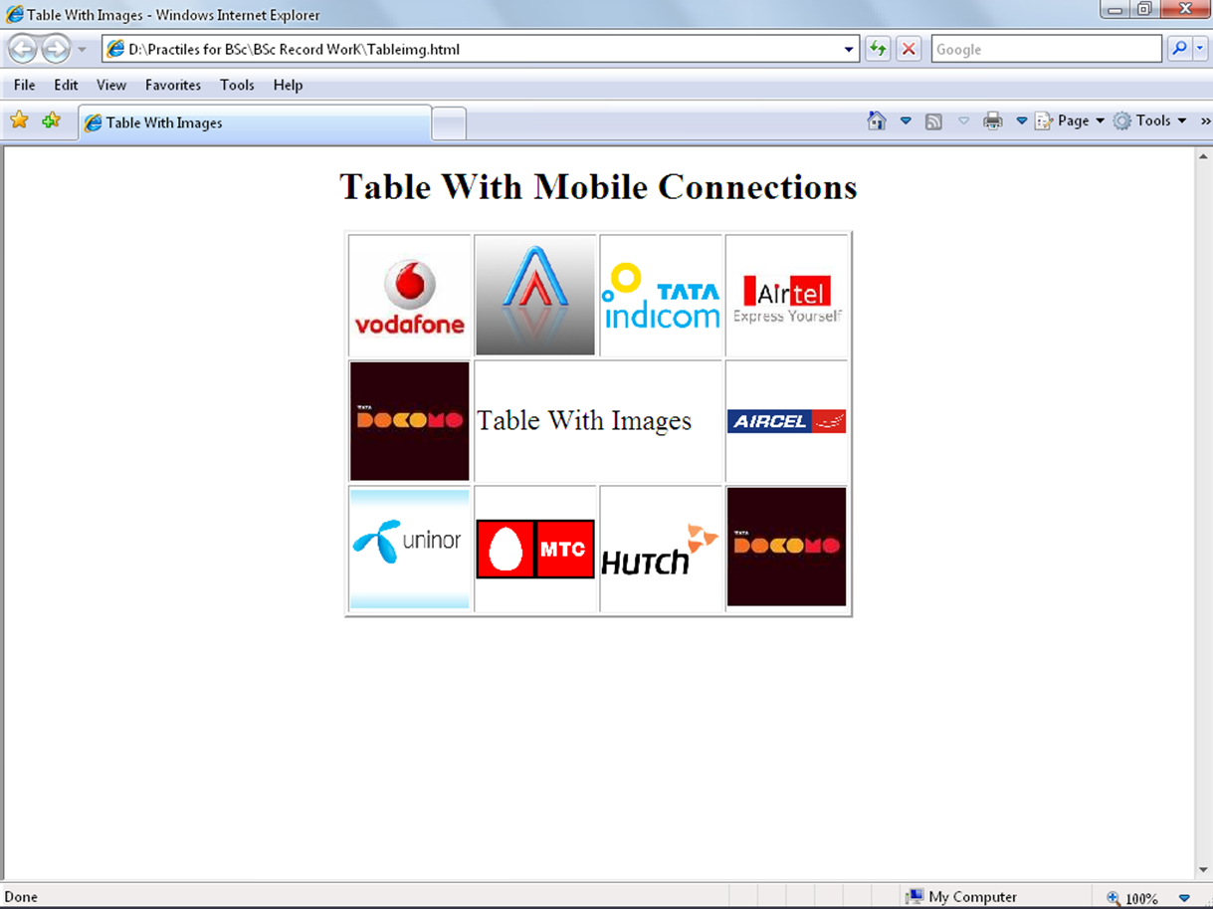

1. Design The page as follows
   * 1. 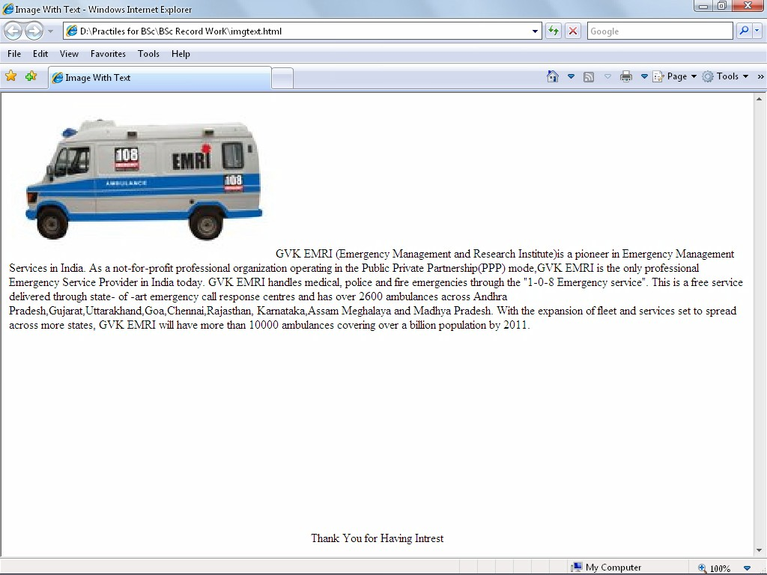
2. Explain hyper link example with target attribute as follows.

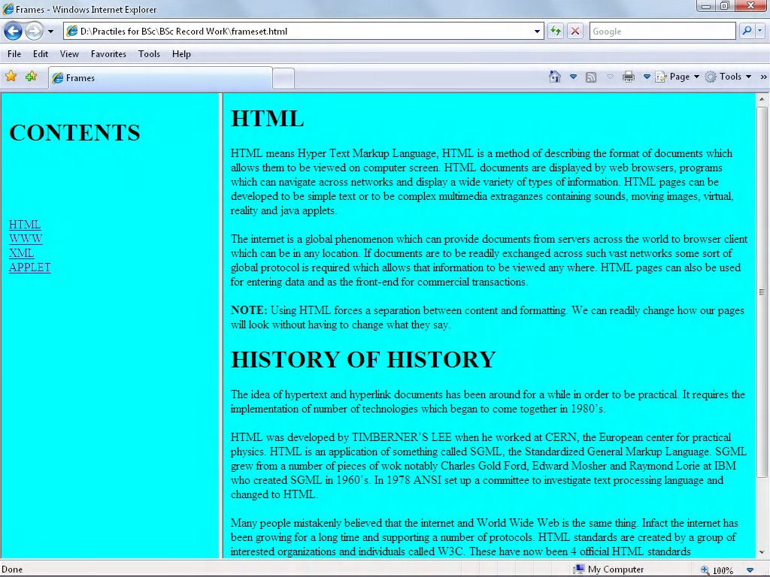

1. Create a java script program to accept the first, middle, last names of user and print them.
2. Write a java script program to add two numbers.
3. Write a java script program to find the factorial of given number.
4. Write a java Script program to print all prime numbers.
5. Write a java script program to sort the array (Bubble Sort).
6. Write a java script program to implement Stack methods in an Array.
7. Write a java script program to “Wish a user” at different hours of a day.
8. Create a web page of customer profile for data entry of customer’s in a Hotel, the profile should include Name, Address, Age, gender, Room Type (A/C, Non- A/C or Deluxe), Type of payment (Cash, Credit/Debit Card or Coupons).
9. Create an Online Bio-Data Form for the Current Employees in the organization.
10. Design the simple Calculator.
11. Write DHTML program to give different colors for different heading tags.
12. Using CSS invert the behavior of the <h1> to <h6> tags.
13. Create a sample code to illustrate the Inline style sheet for your web page.
14. Create a sample code to illustrate the External style sheet for your web page.
15. Create a sample code to illustrate the embedded style sheet for your web page.
16. Create a sample code to illustrate the procedure of creating user defined classes in CSS.
17. Write well-formed" XML file to manage a BOOKSTORE
18. Create a "well-formed" XML file.  Pick a topic related to your term project (or any topic of your choosing). For example, for a weather application, create an XML file describing a weather event including date, time, temperature, rainfall, etc.
19. Develop an HTML document for a web page of your favorite cinema actress. Design the page with using CSS for attractive background color, text color and back ground.
20. Write an XML document that describes an address book containing address; each contact has a name and address. An address should contain attributes for street name, state and phone number. The attributes value for state should not contain spaces, for example “New York” would invalidate the XML document. The attributes value for a phone no must contain hyphens and no spaces.
21. Write a DTD from XML document that stores company profiles each company is represented by a company element. Profiles must contain a name element and a tour element. Element tour prints to a JPG Image or to and HTML page that relates to the company element tour should specify that type of image or document to which it points.
22. Briefly describe each element type element type declaration.

Name (firstname, middlename, lastname)

Test (question, answer)

Discussion (agenda, (issues, solutions) *)

1. Crate an XML document that marks up the nutrition facts for a package of Grandma Dentals Cookies. A package of Grandma Dentals Cookies has a servings size of 1 package and the following nutritional value per servings 260 calories, 100 fat calories, 11 grams of fat, 2 grams of saturated fat, 5 million of cholesterol, 210 milligrams of sodium, 36 grams of total carbohydrates, 2 grams of fiber, 15 grams of sugars and 5 grams of protein.
2. Write a program to upload a file on server using PHP.
3. Design a form and post values from the form and send it to the database.
4. Create a page which displays current date and time on the web page using PHP.
5. Design a web page for MCA department with having logo of KIET and information about the faculties.
6. Write a program to send an email using email service of Gmail.
7. Through program explain how array stores data in PHP.
8. Design a login page using PHP.
9. Using program describe Filter is provide security for the web applications.
10. Write a small e-commerce portal website using PHP
11. Write online examination website using PHP